- Open the email and download attached registration file. Please don’t open the file in Google chrome or I.E. Make sure you download the file to your computer.
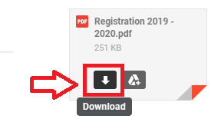
- Once you have the file downloaded go to the download’s location and open the file by right clicking on the file and select Open with Adobe Reader or Adobe Acrobat. Please don’t use Google chrome to complete the form as you will be unable to save the changes.
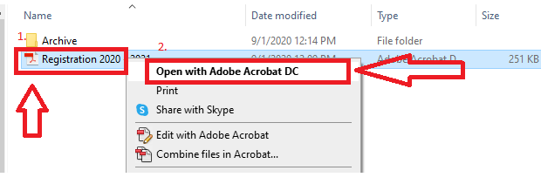
- Once you have completed the form click on File option and select Save As option. Please save the file as the Child’s First and Last name Registration Form (I.E Bob William Registration Form

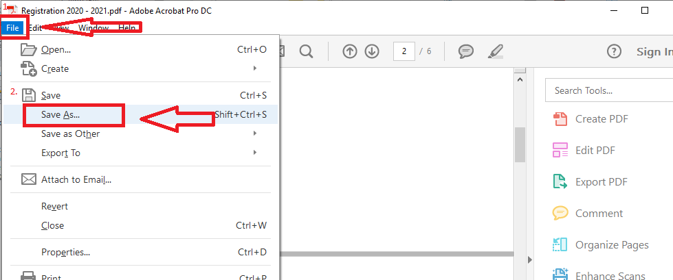

- To make sure you information was saved in the form close the saved copy then open it again to verify that information was saved properly. If not you will have to re-enter the details starting from steps 2 or 1.
- Once you have verified please email the document to crusadersadventurerclub@gmail.com.

